Name: Sergio Gutierrez

bitbucket Repo: <https://bitbucket.org/SergioZGutierrez/homework/src/master/>

Exercise 5 (there’s two exercises/apps, within exercise 5):

These are the two folders containing my two apps:

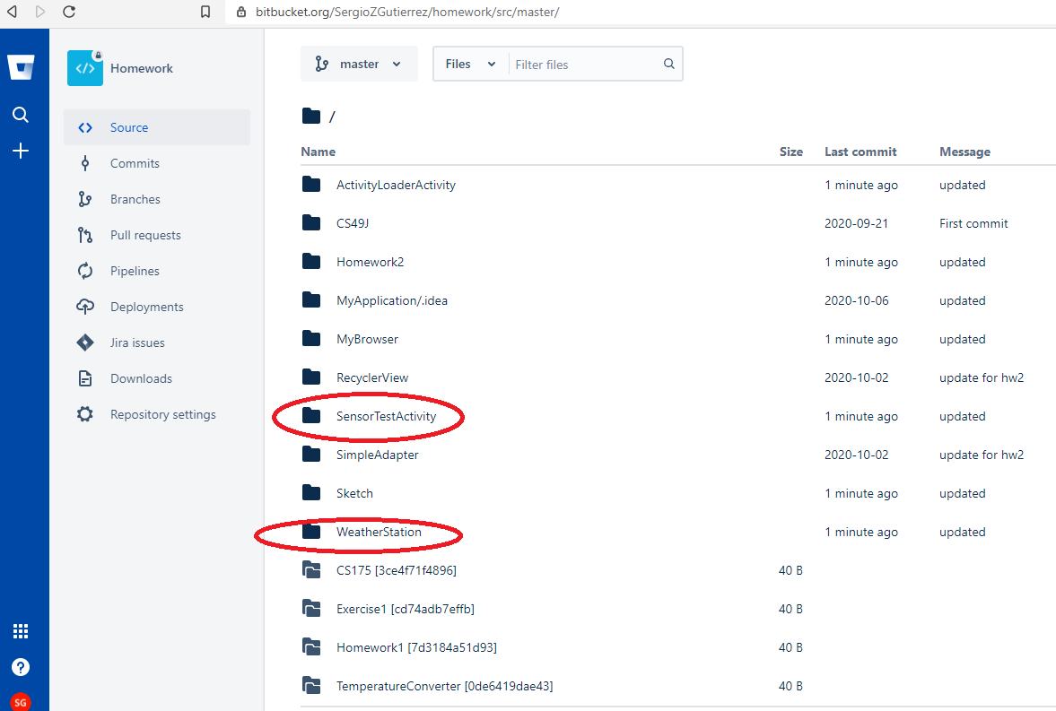

Exercise 1:

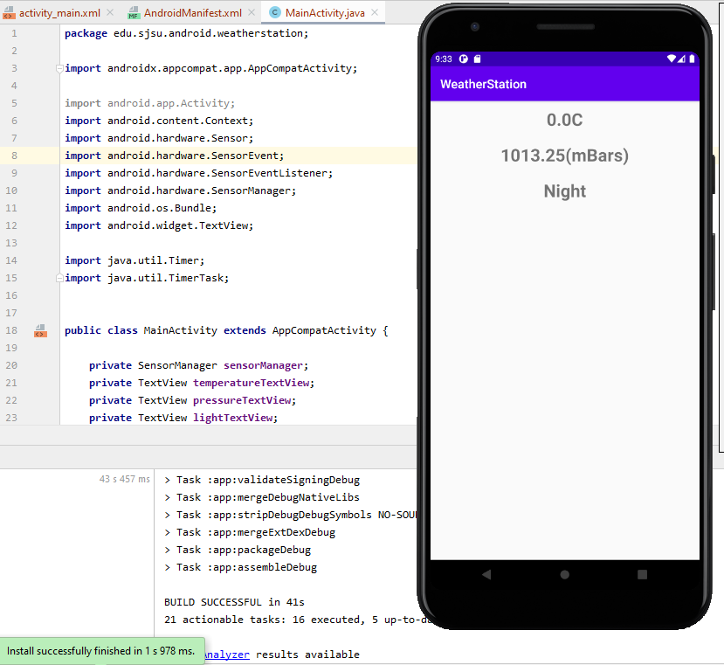

Exercise 2:

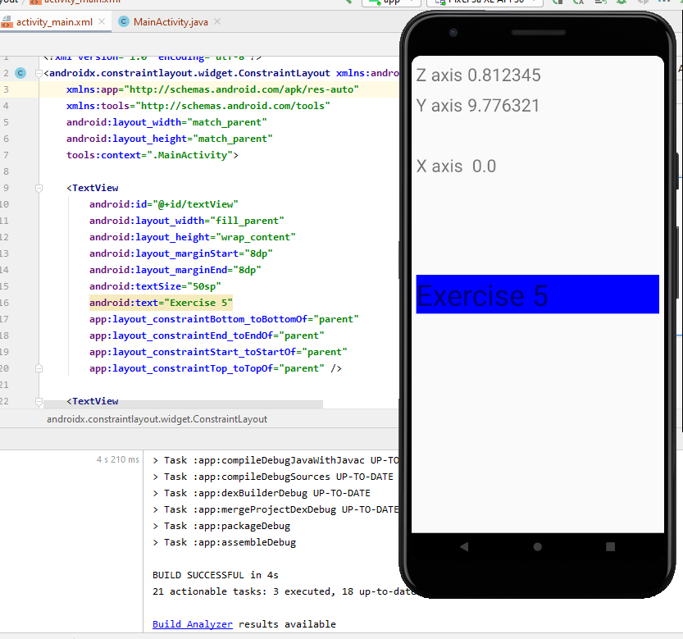

The exact pathways of where the .java files are located in my repository are:

<https://bitbucket.org/SergioZGutierrez/homework/src/master/WeatherStation/app/src/main/java/edu/sjsu/android/weatherstation/>

and:

<https://bitbucket.org/SergioZGutierrez/homework/src/master/SensorTestActivity/app/src/main/java/edu/sjsu/android/sensortestactivity/>